Create Block Volume with ORM Stack

Contents

1. Introduction 1
2. Workflow diagram to deploy the stack 1
3. Create stack for Block Storage 2
4. Plan the Job 5
5. Apply the Job 6
6. Verify in the Console 8
7. Destroy the stack (if required) 9

Introduction
Block Volume provides high-performance network storage capacity that supports a broad range of I/O intensive workloads.
The Oracle Cloud Infrastructure Block Volume service lets you dynamically provision and manage block storage volumes. You can create, attach, connect, and move volumes, as well as change volume performance, as needed, to meet your storage, performance, and application requirements. After you attach and connect a volume to an instance, you can use the volume like a regular hard drive. You can also disconnect a volume and attach it to another instance without the loss of data.

Workflow diagram to deploy the stack

Below diagram shows how the Terraform Artifact are applied in the OCI. While creating a ORM stack, using terraform deliverables Init, Plan and Apply is the flow to provision the resource in the OCI. We can have the deliverables in any of below.
- GitLab/GitHub Repo
- Bitbucket
- Can be in folder/.zip in the local disk
- Object Storage Bucket
- Can be in compartment
- Oracle provided Template


Create stack for Block Volume

Go to OCI Console Developer Services Resource Manager Stacks select the compartment Create Stack

My Configuration Folder Browse Select the “Block Volume” folder that contains the artifacts Upload

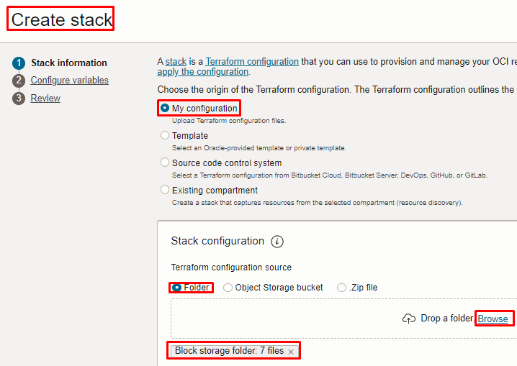

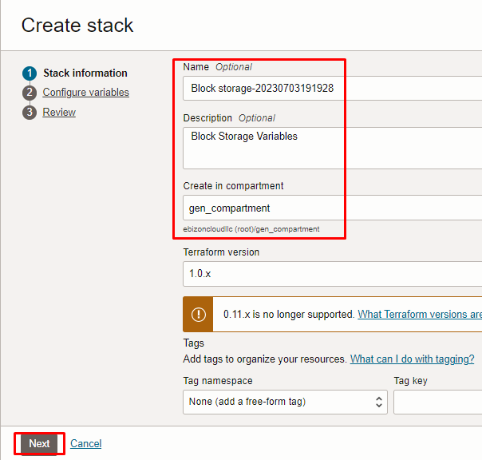

Click “NEXT”

Select the parameters as per the below screen,

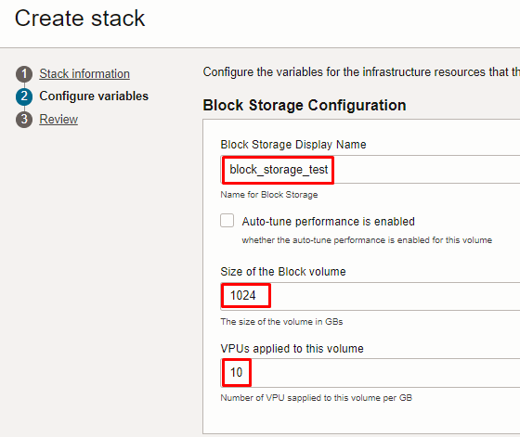
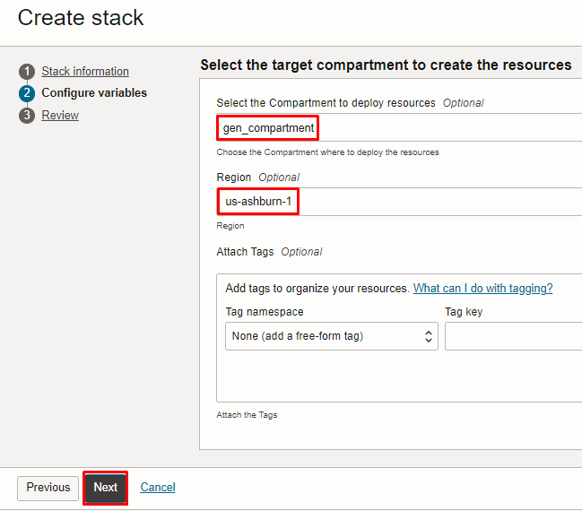

Note: select the right compartment to apply the stack in the OCI

Click “NEXT” Click “CREATE”

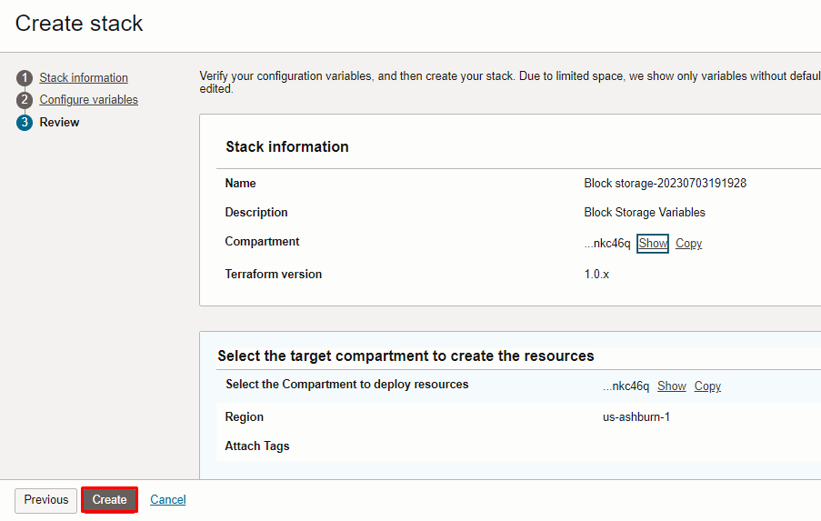

Plan the Job

Click the “Plan”

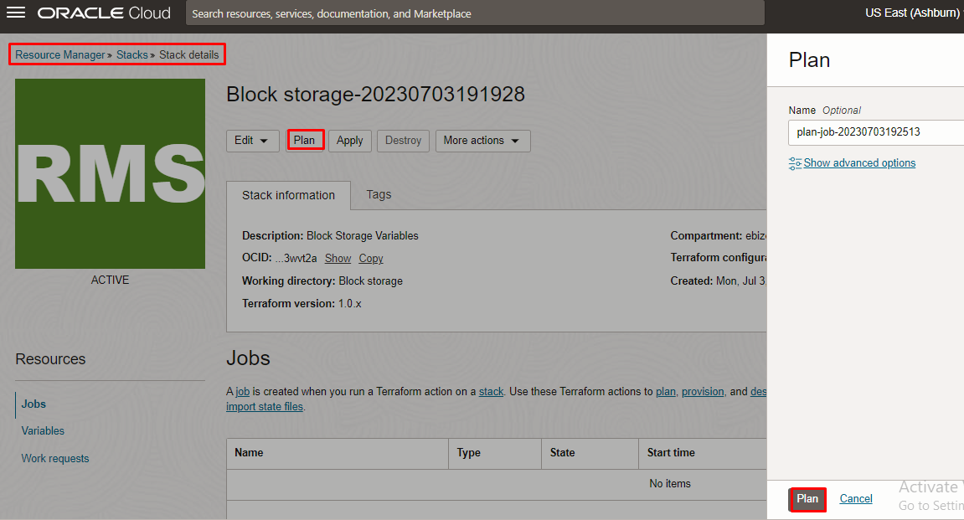

Verify the Plan is successful.

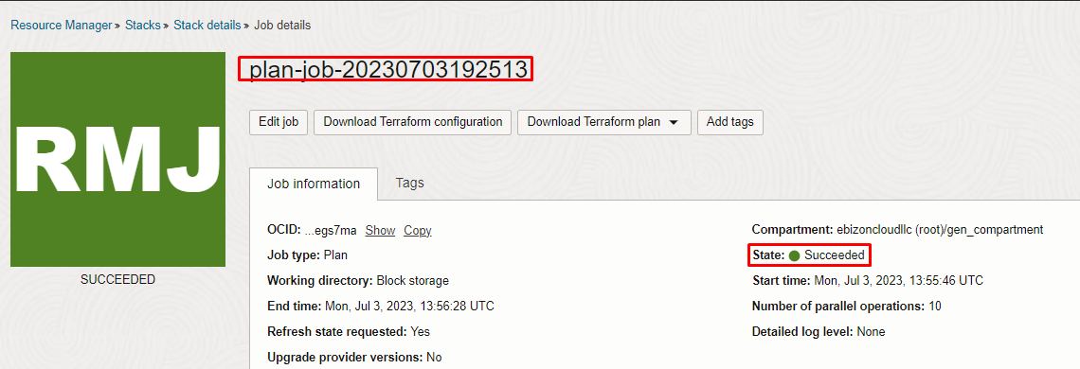
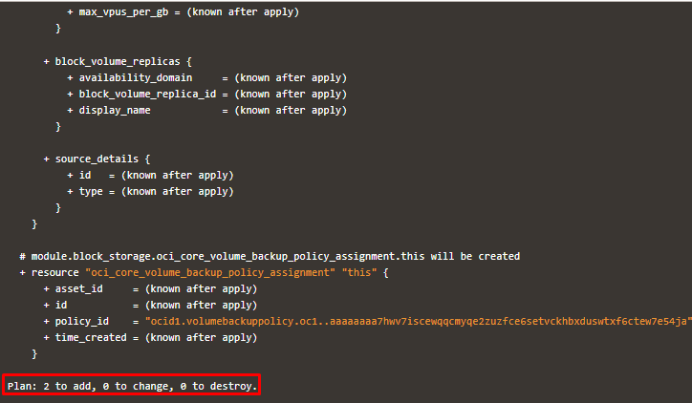

Apply the Job

Once the “plan” is success, now click “Apply”

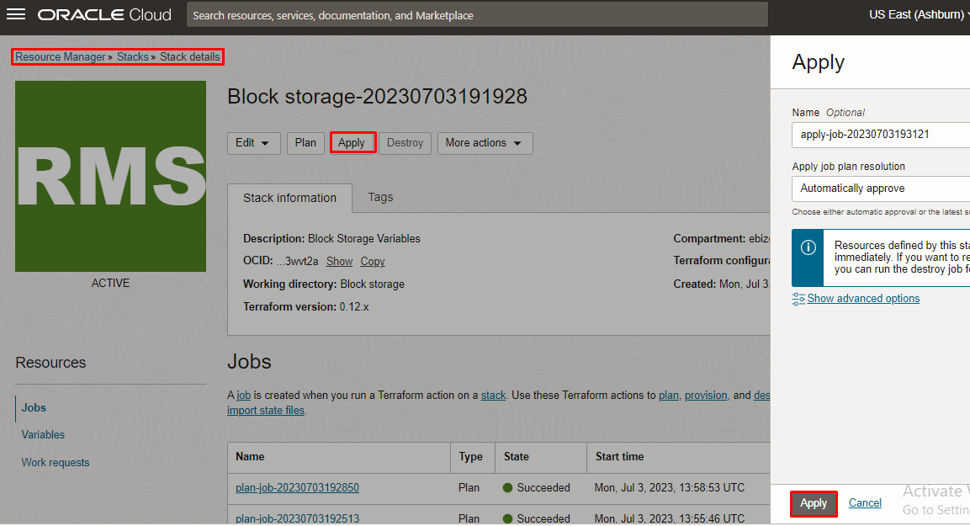

Verify the Apply is successful.

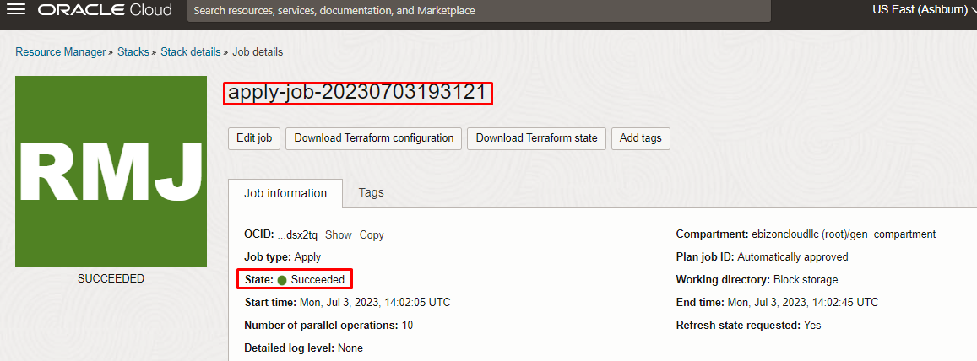
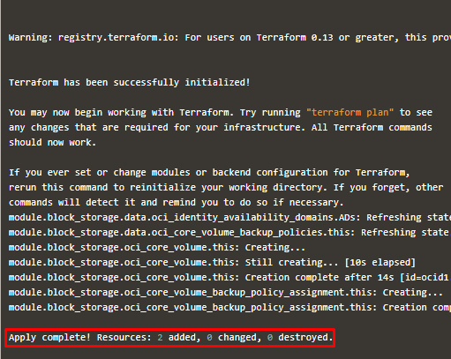

Verify in the Console

Go to OCI Console Storage Block Storage
Note: Select the specified compartment (in the step 2) to get the output.

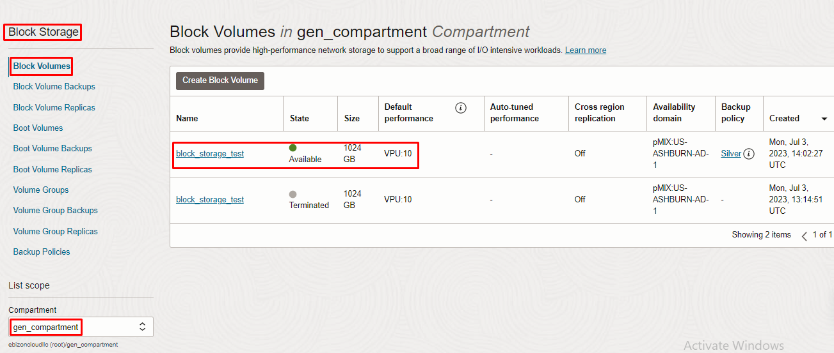
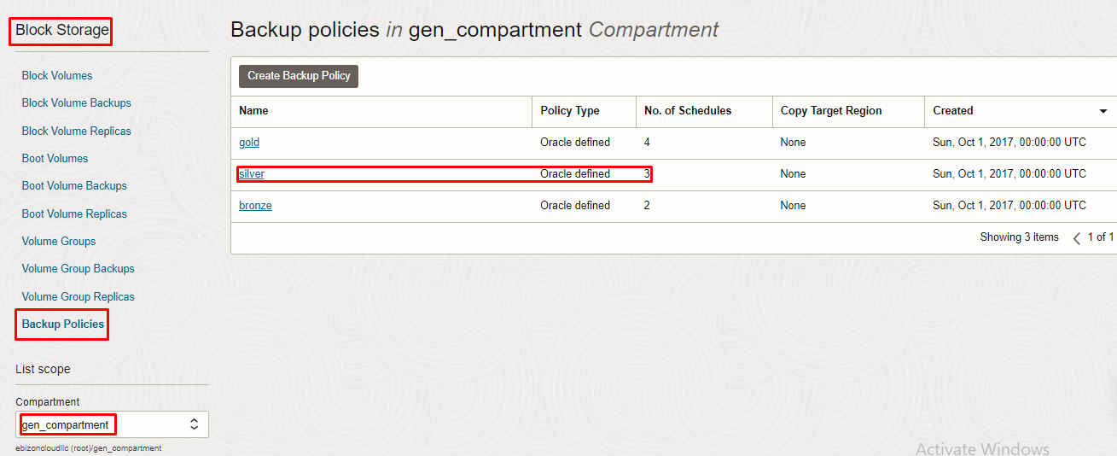

Destroy the stack (if required)

Create a destroy job in Resource Manager to release resources associated with a stack and clean up the tenancy. Once destroyed data cannot be recovered from resources.

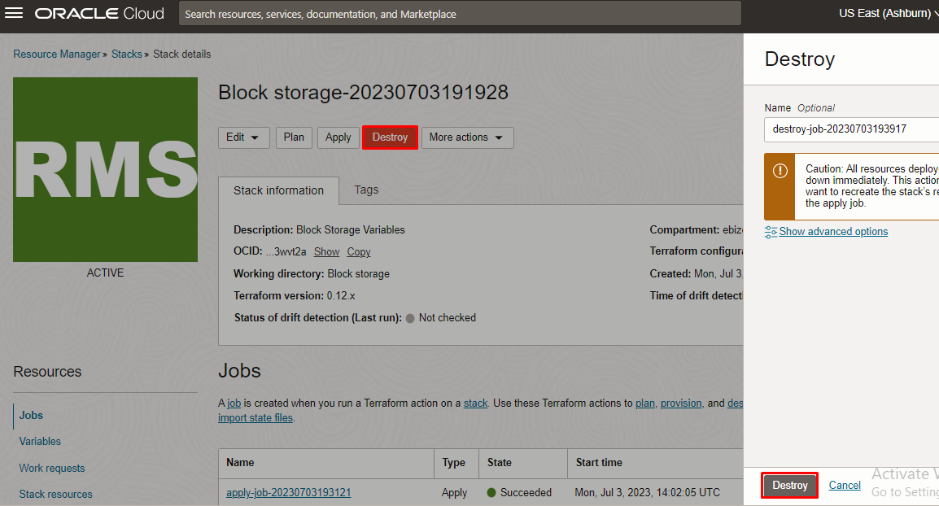

# END #

